HR ANALYTICS DASHBOARD
1. Project Title
HR Analytics Dashboard using Tableau
2. Abstract
Human Resource analytics plays a vital role in understanding workforce behavior, improving employee retention, and supporting data-driven decision-making. This project focuses on building an interactive HR Analytics Dashboard using Tableau to analyze employee demographics, attrition trends, job satisfaction, income distribution, and workforce patterns across age, gender, and business travel. The dashboard enables HR teams and management to quickly identify key insights related to employee attrition, performance, and compensation, thereby supporting strategic planning and policy formulation.
3. Objective of the Project
The primary objectives of this project are:
- To analyze employee attrition patterns across different demographics
- To understand the relationship between gender, job satisfaction, and attrition
- To study the impact of business travel on employee attrition
- To visualize income, working hours, and age distribution of employees
- To provide an interactive HR dashboard for decision-makers
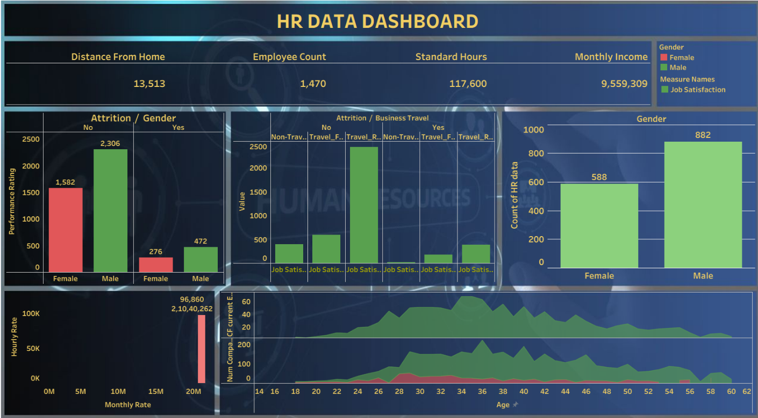
4. Dataset Description
The dataset used in this project is an HR employee dataset containing information related to employee demographics, work patterns, and compensation.
Key Attributes in the Dataset:
- Employee Count – Total number of employees
- Gender – Male / Female
- Age – Age of employees
- Attrition – Employee attrition status (Yes / No)
- Distance From Home – Distance between employee residence and workplace
- Business Travel – Frequency of business travel (Non-Travel, Travel Frequently, Travel Rarely)
- Job Satisfaction – Job satisfaction rating
- Monthly Income – Employee monthly income
- Hourly Rate – Employee hourly wage
- Standard Hours – Total standard working hours
5. Tools and Technologies Used
- Tableau Desktop – For data visualization and dashboard creation
- Microsoft Excel – For dataset storage and basic preprocessing
- Data Visualization Techniques – Bar charts, KPI cards, area charts, and comparative analysis
6. Dashboard Overview
The HR Analytics Dashboard is designed with a clean and professional layout, consisting of KPI indicators and multiple visualizations to provide both high-level summaries and detailed insights.
Key Performance Indicators (KPIs):
- Total Employees: 1,470
- Total Distance From Home: 13,513
- Total Standard Hours: 117,600
- Total Monthly Income: 9,559,309
7. Visual Analysis and Insights
7.1 Attrition by Gender
- Male employees show higher attrition compared to female employees.
- Majority of employees fall under the "No Attrition" category, indicating stable retention.
7.2 Attrition by Business Travel
- Employees who travel frequently show a relatively higher attrition rate.
- Non-traveling employees exhibit lower attrition, suggesting travel may impact job satisfaction.
7.3 Gender Distribution
- Male employees (882) form a larger portion of the workforce compared to female employees (588).
7.4 Income and Hourly Rate Analysis
- Monthly income distribution shows a wide range, indicating varied job roles and seniority levels.
- Hourly rate analysis helps identify compensation spread across employees.
7.5 Age Distribution Analysis
- Majority of employees fall within the age range of 25–40 years.
- Attrition is more noticeable among mid-career employees.
7.6 Job Satisfaction Insights
- Higher job satisfaction levels are associated with lower attrition.
- Employees with frequent travel show lower job satisfaction scores.
8. Business Insights
- Business travel frequency is a significant factor influencing attrition.
- Gender-based attrition patterns suggest the need for targeted retention strategies.
- Job satisfaction strongly correlates with employee retention.
- Age and income analysis can help identify high-risk attrition groups.
9. Conclusion
This HR Analytics Dashboard successfully demonstrates how data visualization can transform raw HR data into meaningful insights. The dashboard enables organizations to monitor attrition trends, evaluate employee satisfaction, and optimize HR strategies. By leveraging Tableau, complex HR data is converted into intuitive and interactive visuals that support informed decision-making.
10. Future Enhancements
- Incorporate department-wise and role-based analysis
- Add predictive analytics for attrition forecasting
- Integrate real-time HR data sources
- Include performance and promotion trend analysis
11. Acknowledgement
This project was developed as part of a Tableau final project to demonstrate practical skills in data analysis, visualization, and dashboard design using real-world HR data.

